**ASSIGNMENT NO # 02**

|  |  |
| --- | --- |
| NAME: | Wajahat Nazir, Muhammad Ahmad |
| REGISTRATION NO: | SP24-BSE-122-(B)  SP24-BSE-066-(B) |
| SUBMITTED TO: | Sir Shahid Bhatti |
| SUBJECT: | OOP |

In this assignment we inserted sockets in messaging app where each server and client can send and receive messages from each other and previous methods like delete messages add contact etc are also inserted in this code accordingly but there are few bugs too.



One person will run server and other will Client…

This is the first display of client output …

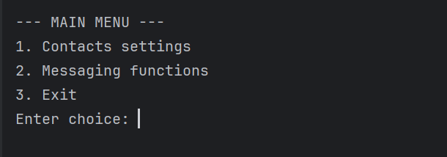

Here main menu is called after building connection when RUN thread is in action…

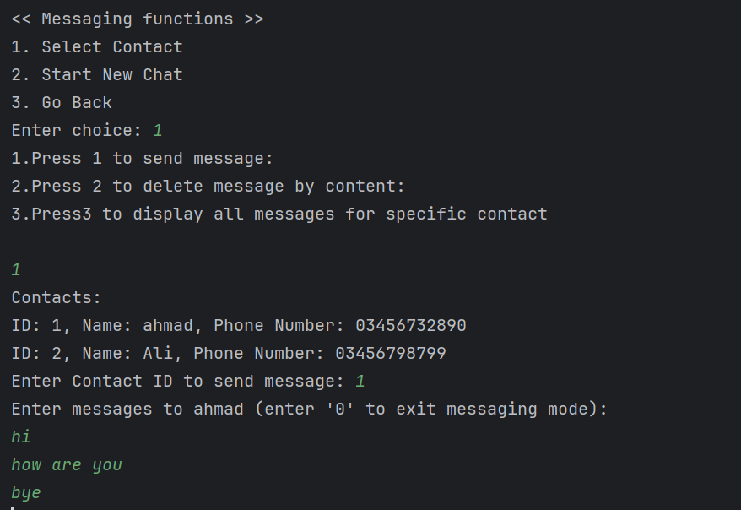

This function shows the working of messaging where one can send message to specific contact delete specific message and can also view all messages.

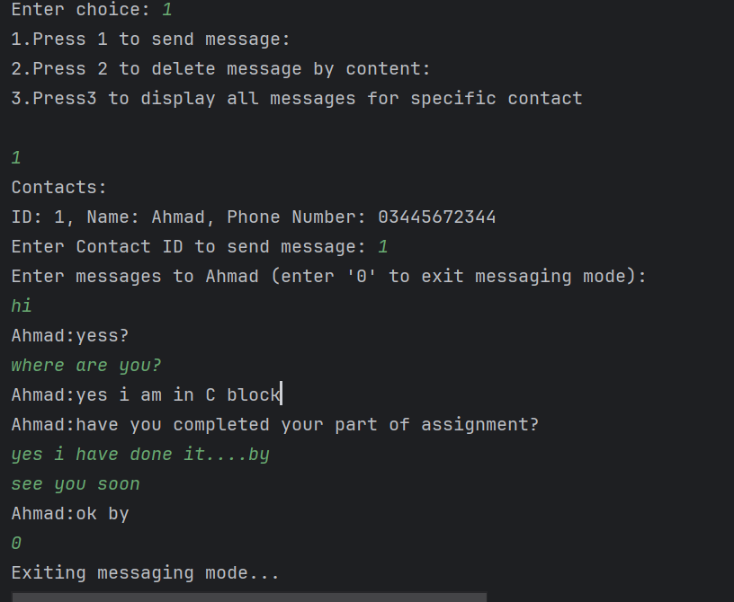

Here is the two way communication of Client

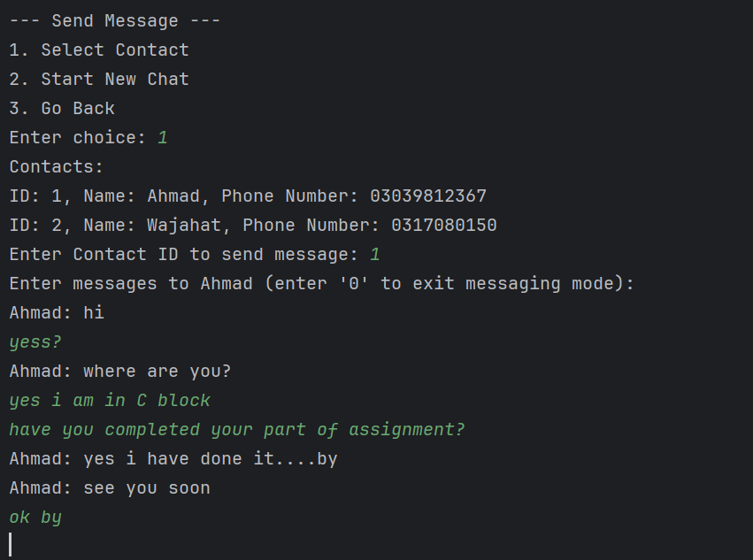

While this is the 2 way communication shown by Server…

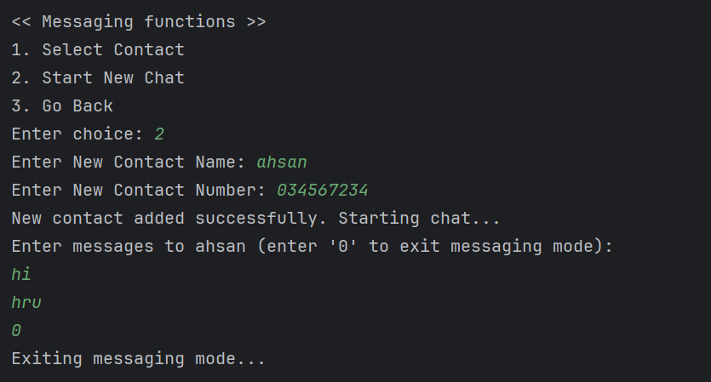

By this message we can add a new contact and directly send a message to that contact.

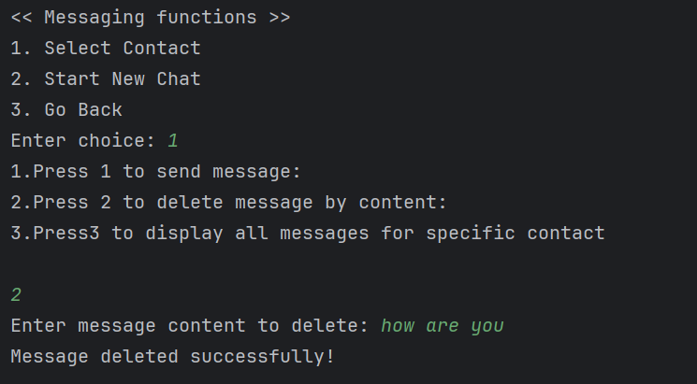

We can delete any message for any contact by its content….

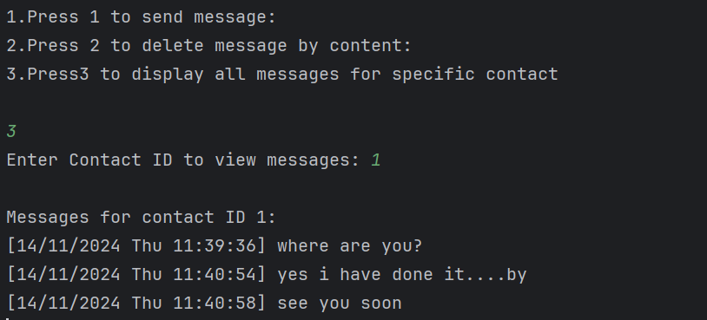

This message is displaying all messages but only send by client to server this is the bug in my code.